ALGAV

3DE

1220514 – Liam Saliën

1220528 – Juuso Jalava

1220379 – Benjamin Moreira

1220459 – Patryk Pas

1220448 – Miika Kauppinen

Contents

1. Introduction 3

2. Creation of the initial population of the Genetic Algorithm (GA) 3

3. Random Crossover between individuals of the population 5

4. Selection of the new generation of the population 5

5. Efficacy Analysis comparing the better individual of the created GA compared with the better from the initial version of the GA. 6

6. Parametrization of the ending condition of the AG 7

7. Use of the GA to handle several trucks, representing in the same chromosome the deliveries of the several trucks. 8

8. Study of methods of Machine Learning 8

9. From a solution obtained from the GA it is envisaged to be able to allow dynamic changes 9

10. Conclusions 11

# 1. Introduction

TBD

# 2. Creation of the initial population of the Genetic Algorithm (GA)

For this task, the example solution was adapted to our solution, and modified to include 2 different heuristics solution, and then randomly generated deliveries routes (from warehouse to warehouse):

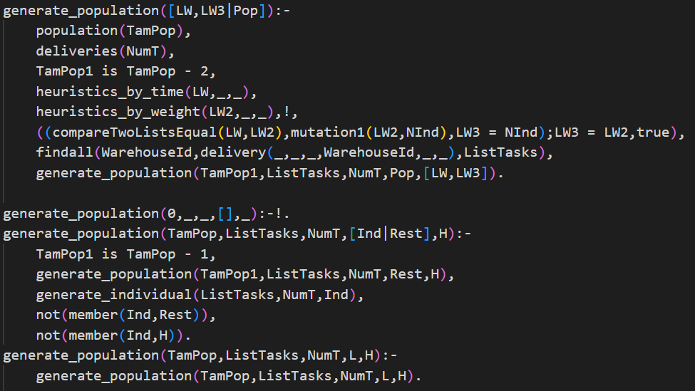

Figure

The first generation population predicate (with one variable) will read the amount of deliveries that are in the system, and after that it will subtract the amount of individuals that are expected by 2, as it was required to include two solutions obtained by two different heuristics. The two heuristics used in our solution are by time, and by weight.

Furthermore it checks if the two solutions doesn’t equal each other (which uses a predicate that compares every single item in two lists).

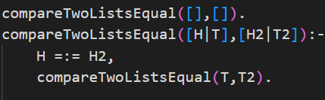

Figure

If this is the case, a mutation will be done on the second solution (obtained by the weight heuristic).

After this, for the rest of the individuals, another predicate will be called (and will include a list that already contains the two obtained solutions).

This predicate will be recalled until the TamPop is 0, which means we reached the amount of individuals we had to create. It will also check every single time if the generated solution is not already a part of the randomly generated deliveries routes list, and of the list that contains the two solutions obtained by the heuristics.

# 3. Random Crossover between individuals of the population

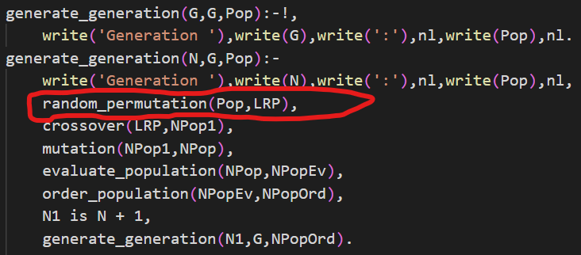

Figure

For this task the generate generation predicate was modified. The build-in predicate random_permutation/2 is added after the current generation and their individuals are written to the screen.

Right before the written population will go through crossover and mutation etc, it is shifted by this build in predicate, so that the order will be different. Because of this, crossover doesn’t always happen between the first and second warehouseId, etc., etc.

*Example of this predicate in working:*

If we use random_permutation on the following list:

*[[9,11,1,8,3]*463.7758474576272,[11,8,1,3,9]*486.5362288135594,[11,8,3,1,9]*508.935593220339,[3,1,8,9,11]*510.73241525423737,[11,3,9,8,1]*537.482627118644]*

It might lead to this result:

*[[11, 8, 3, 1, 9]*508.935593220339, [11, 8, 1, 3, 9]*486.5362288135594, [9, 11, 1, 8, 3]*463.7758474576272, [11, 3, 9, 8|...]*537.482627118644, [3, 1, 8|...]*510.73241525423737]*

This way our solution works more randomly, as well as the crossover takes place more randomly.

# 4. Selection of the new generation of the population

The selection of the new generation of the population considers the elements of the previous population and their descendants after crossover and mutation. It is important to consider that the mutation can change a descendant after crossover, potentially resulting in a better individual.



Figure

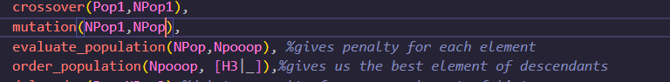

Figure

The two best individuals of each element (previous generation (H) and descendants (H3), *Figure 4 and 5*) are automatically included in the new generation. For the remaining elements, a tournament selection process is used to determine which individuals will be included in the new generation. In this process, any element can proceed, but individuals with better evaluations have a higher probability of being selected.

To implement this selection process, we can define a predicate that takes in the previous generation and the descendants and returns the new generation. This predicate can first identify the two best individuals from the previous generation and descendants, and then use the tournament selection process to determine the remaining elements of the new generation.

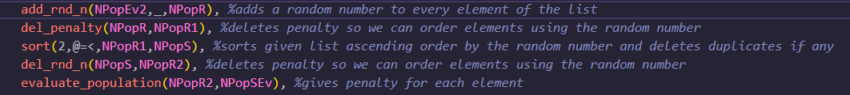

Figure

The tournament selection can be implemented using a random permutation, where we randomly select a group of individuals and compare their evaluations to determine the winner. The winner of the tournament is then added to the new generation, and the process is repeated until all the remaining elements have been selected.

# 5. Efficacy Analysis comparing the better individual of the created GA compared with the better from the initial version of the GA.

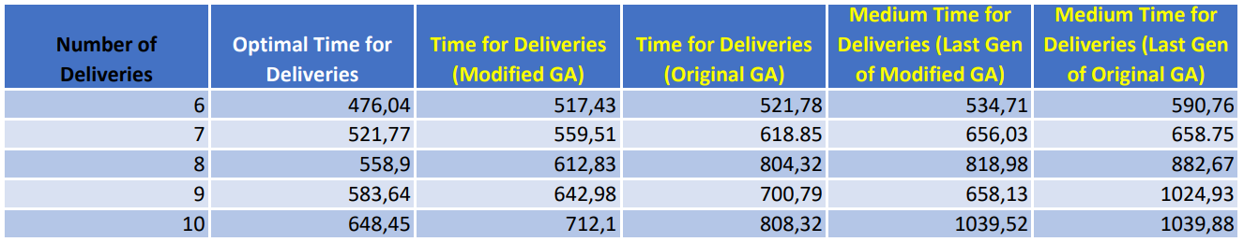

Figure . Table of results of optimal solution, original GA and modified GA.

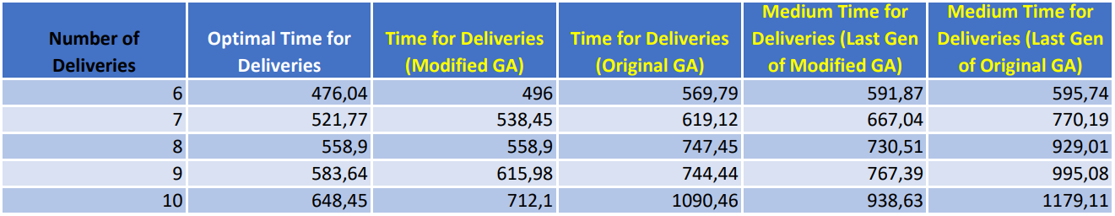

Figure . Table of results of optimal solution, original GA and modified GA. Different input values than Figure 4.

For the analysis we used the original list of deliveries given to us at the start of project. For *Figure 7* the number of generations we used was 6, population size 5, crossover probability 50 % and mutation probability 25 %. In *Figure 5* for modified GA we used 100 generations, population size 30, crossover probability 50 % and mutation 25 %. For original GA in *figure 8* we used 1000 generations, population size 5, crossover probability 10 % and mutation 5 %. In optimal solution the time needed to make higher number of deliveries is always higher. In theory that should also be the case Genetic Algorithm, but given the randomness in GA the better solution is not always found. Increasing the number of generations allows modified GA to find better solutions, but that’s not the case with original GA since it doesn’t save the better solutions for new generations.

# 6. Parametrization of the ending condition of the AG

Figure

The regular flow of a Genetic Algorithm flow (including crossover, mutation, etc.) was modified by including a stabilization check. If the populations of the latest generations (assembled by the append predicate) are all the same, we say it is stabilized (will be explained further below) and the predicate can stop. If not, it should do all the modifications and recall itself to generate new generations as long as it is not stabilized OR we didn’t reach the request amount of generations as mentioned/given during the initialization.

Figure

We agreed that a population is “stabilized” when 10 generations after each other do have the same populations. This is a random number that was chosen, as it cannot be too small, and not too big, and stabilization doesn’t have only one possible solution/meaning (everyone can choose another definition of when something is “stable”). Is there a possibility new solutions will be created after this? Yes, but the obtained solution (when our program says it’s stable), is valid enough and won’t differ that much from further generated possibilities (as 10 times equal is already a lot).

These predicate firstly checks if there are already more than 10 generations, and if this is the case, it will reverse the generations as we only need the 10 latest ones. It will then check the latest population with the 9 populations that were generated before that one, and if all are equal, we can say it is stabilized.

# 7. Use of the GA to handle several trucks, representing in the same chromosome the deliveries of the several trucks.

TBD

# 8. Study of methods of Machine Learning

*Machine learning (ML)* is a subset of AI that is focused on teaching computers to learn from data and to improve it with experience instead of being explicitly programmed to do so. The algorithms are trained to find patterns in large data sets to make the best decisions and predictions based on that analysis.

Those applications improve with use and become more accurate the more data they have access to.[1]

As Machine Learning is a very big topic to cover, there are a lot of methods present to actually apply it to certain problems.

Below we study multiple of those methods, in order for us to both understand the different Machine Learning methods, and how to apply them to our problem of performing deliveries from warehouse to warehouse (starting from one central warehouse located in Matosinhos), and taking into account the battery levels (that shouldn’t go below a previously stated minimum of 20%) and the most optimal route that has the lowest cost (which is also based on the total weight of the electric truck and its payload):

1. A Machine learning method that can be used to estimate the energy consumption of the electric trucks during the deliveries as accurate as possible is the **Bayesian** Machine learning method, or more precisely, the **Bayesian regression** method. It’s a type of Supervised Learning.

This will obtain/estimate both the optimal as the variance (of) energy consumption based on an initial prior, and afterwards improve this precision by combining it with (new) empirical data (= data based on what is experienced/retrieved earlier).

Thanks to the obtained variance, this method makes it also possible to plan routes more efficient and predict the probability of higher energy consumptions.

The method works as follows:

It needs to find 2 coefficients alpha and beta for each road link (randomly), to calculate the energy probability distribution for that road link. For this it first computes a *prior* based on **map data and vehicle model**, secondly finds the *likelihood* based on **measured data** (from vehicles driving on the road) that will be combined with this prior to become the *posterior*, and finally this will lead to the *posterior predictive*.

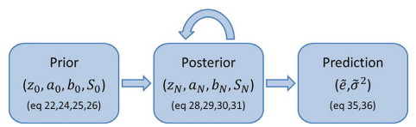

Figure

If we look into more detail, the likelihood function contains information regarding the total energy consumed, the total mass and the average speed. The function that is obtained using among other things matrix notations is combined with the prior that consists of both a mean (obtained by Gaussian distribution) and a variance (obtained by Inverted Gamma distribution). To retrieve the initial data for the prior, a probabilistic speed profile for each road link in the road network should be used.

The posterior method will then be a result of these two combined, and thanks to ML the system can learn recursively by using the newest measurements of energy, mass, and speed every time a vehicle drives a certain road link.

The result in the end will then be a posterior distribution of coefficients alpha and beta to predict energy consumption when given an input of mass and speed for a certain road link.

# 9. From a solution obtained from the GA it is envisaged to be able to allow dynamic changes

First, we must make deliveries dynamic so we can do changes to it (figure 12).



Figure . Predicate that makes delivery dynamic.

We have predicates for creating (figure 13), updating (figure 14), and deleting (figure 15) a delivery. Each predicate asks needed details from the user and carries out given task.

*Add_delivery* asks user *Id, date, weight, destination warehouse, time to load and time to unload*. After that it uses *asserta* asserts a clause into the beginning of database. After that it writes “New delivery added” and ends the predicate.

Figure . Predicate to add delivery.

*Change_delivery* asks user Id and load. Then gets all other details of the delivery with given id, *retractall* deletes that delivery from the database we want to update and *asserta* creates an updated one. After that it writes “Delivery modified” and ends the predicate.

Figure . Predicate to change delivery.

*Delete_delivery* asks user Id of the delivery we want to delete and *retractall* deletes that delivery from the database. After that it writes “Delivery deleted” and end the predicate.

Figure . Predicate to delete delivery.

To get the program to work with dynamic changes we need to make predicate which gives us the number of deliveries when we need (figure16).

Figure . Predicate to get number of deliveries

We created predicate *generate_dynamic* (figure 17), Which runs until *generate_dynamic1* stops. At the end of *generate_dynamic1, changes* predicate (figure 18) asks user to give 1, 2, 3 or 0. 0 or any else number or letter stops the predicate.

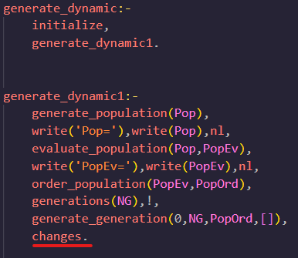

Figure . Generate predicate for dynamic changes

Figure . Predicate which asks to type a number and do stuff according to it.

# 10. Conclusions

TBD

1. SAP. (n.d.). *What is machine learning? | Definition, types, and examples | SAP Insights*. https://www.sap.com/insights/what-is-machine-learning.html